**2017**

1. When does the nucleus of an atom tend to be radioactive [2 marks]

**2016**

1. Arrange α, β, and γ rays in ascending order with respect to their [3 marks]
   1. Penetrating power
   2. Ionising power
   3. Biological effect
2. Represent the change in the nucleus of a radioactive element when a β particle is emitted [1 mark]
3. What is the name given to elements with same mass number and different atomic number [1 mark]
4. Under which conditions does the nucleus of an atom tend to be radioactive [1 mark]
5. An element ${}_{Z}^{A}S$ decays to ${}_{85}^{222}R$ after emitting 2 α particles and one β particle. Find the atomic number and atomic mass of the element S [2 marks]
6. A radioactive substance is oxidised. Will there be any change in the nature of its radioactivity? Give a reason for your answer? [2 marks]

**2015**

1. An atomic nucleus A is composed of 84 protons and 128 neutrons
   1. The nucleus ‘A’ emits an alpha particle and is transformed into nucleus ‘B’. what is the composition of nucleus ‘B’
   2. The nucleus ‘B’ emits a beta particle and is transformed into nucleus ‘C’. what is the composition of nucleus ‘C’
   3. Does the composition of nucleus ‘C’ change if it emits gamma radiations? [3 marks]
2. Complete the diagram as given below by drawing the deflection of radioactive radiations in an electric field [3 marks]

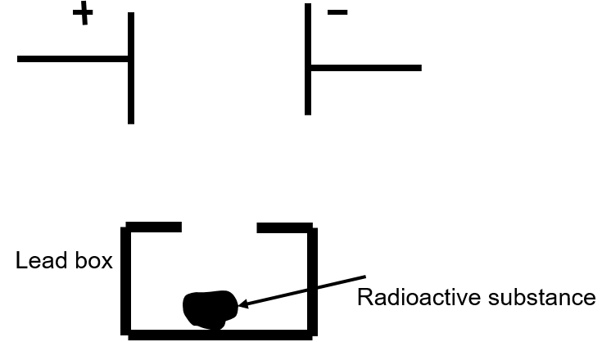

1. State any two precautions while handling radioactive substances [2 marks]

**2014**

1. A nucleus ${}_{11}^{24}{Na}$ emits a beta particle to change into Magnesium (Mg)
   1. Write the symbolic equation for the process
   2. What are numbers 24 and 11 called
   3. What is the general name of ${}_{12}^{24}{Mg}$ with respect to ${}_{11}^{24}{Na}$? [3 marks]

**2013**

1. Which radioactive radiations
   1. Can cause severe genetic disorders
   2. Are deflected by an electric field [2 marks]
2. A radioactive nucleus undergoes a series of decays according to the sequence

$$X\underset{→}{β}X_{1}\underset{→}{α}X_{2}\underset{→}{α} X_{3}$$

If the mass number and atomic number of X3 are 172 and 69 respectively, what is the mass number and atomic number of X? [2 marks]

1. What is meant by radioactivity? [1 mark]
2. What is meant by nuclear waste? Suggest one effective way for the safe disposal of nuclear waste? [2 marks]

**2012**

1. Give any two important sources of background radiation [2 marks]
2. What is the value of the speed of gamma radiations in air or vacuum [1 mark]
3. A certain nucleus X has a mass number 14and atomic number 6. The nucleus X changes to ${}_{7}^{14}Y$ after the loss of a particle
   1. Name the particle emitted
   2. Represent this change in the form of an equation [2 marks]
4. A radioactive substance is oxidised. What change would you expect to take place in the nature of its radioactivity? Give a reason for your answer? [2 marks]

**2011**

1. When an alpha particle gains two electrons it becomes neutral and becomes an atom of an element which is a rare gas. What is the name of this rare gas [1 mark]
2. Define radioactivity [1 mark]
3. (i) What happens inside the nucleus that causes the emission of beta particle?

(ii) Express the above change in the form of an equation [2 marks]

1. (i) The nucleus ${}_{84}^{202}X$ emits an alpha particle and forms the nucleus Y. represent this change in the form of an equation

(ii) What changes will take place in the mass number and atomic number of the nucleus Y if it emits gamma radiations [3 marks]

1. During the emission of a beta particle, the …………………. Number remains the same [1 mark]
2. A mixture of radioactive substances gives off three types of radiations
   1. Name the radiation which travels with the speed of light
   2. Name the radiation which has the highest ionising power [2 marks]

**2010**

1. Complete the following nuclear changes
 ${}_{11}^{24}{Na→}{}_{….}^{….}{Mg+}{}_{-1}^{0}β$

 ${}_{92}^{238}{U→}{}_{90}^{234}{Th+…+}energy$ 1. [2 marks]
2. (i) Which radiation produces maximum biological damage

(ii) What happens to the atomic number of an element when the radiation named by you in part (i) above are emitted [2 marks]

**2009**

1. (i) Name the radioactive radiations which have the least penetrating power

(ii) Give one use of radio isotopes

(iii) What is meant by background radiation [3 marks]

1. A nucleus ${}_{Z}^{A}X$ emits an α-particle followed by γ-emission, thereafter, it emits two β-particles to form $X_{3}$

(i) Copy and complete the values of A and Z for $X_{3} {}_{Z}^{A}X \underset{→}{α}X_{1}\underset{→}{γ}X_{3} \underset{→}{2β}X_{3}$

(ii) Out of α, β and γ radiation,

* 1. Which radiation is the most penetrating
  2. Which radiations are negatively charged [4 marks]

**2008**

1. (i) When does the nucleus of an atom become radioactive

(ii) How is the radioactivity of an element affected, when it undergoes a chemical change to form a chemical compound?

(iii) Mention one use and one harmful effect of radioactivity [3 marks]

**2007**

1. (i) Mention two important precautions that should be taken while handling radioactive materials

(ii) State one use of radio-isotopes [3 marks]

1. (i) What happens to the atomic number of an element, when it emits
   1. An alpha particle
   2. A beta particle

(ii) Explain, why alpha and beta particles are deflected in an electric or a magnetic field but gamma rays are not deflected in such a field [4 marks]

1. (i) Name the particles give out during radioactive decay

(ii) Show by equation, the effect on the proton number ‘Z’ and mass number ‘A’ of the parent nucleus brought about by the two types of radioactive decay

(iii) What is carbon-14 dating [4 marks]

**2006**

1. A certain radioactive nucleus emits a particle that leaves its mass unchanged but increases it atomic number by ‘1’. Identify the particle and write its symbol [2 marks]
2. How many alpha and beta particles are emitted when uranium nucleus ${}_{92}^{238}U$ decays to lead ${}_{82}^{206}{Pb}$ [2 marks]

**2003**

1. The isotope of ${}_{92}^{238}U$ decays by alpha-emission to an isotope of thorium (Th). The thorium isotope decays by beta-emission to an isotope of protactinium (Pa). Write down the equations to represent these two nuclear changes [4 marks]

**2002**

1. Mention two possible sources of background radiations [2 marks]
2. An element ‘X’ changes to another element ‘Y’ with the emission of beta particles. Write down the equation showing changes in the nucleus. Take the proton number and mass number of ‘X’ as Z and A respectively [2 marks]
3. Describe briefly two properties of each of alpha and beta particles [4 marks]

**2001**

1. ${}_{12}^{24}{Mg}, α,β, Al, γ$ In the above nuclear reaction,
   1. ${}_{12}^{24}{Mg}$ emits alpha, beta particle and is transformed to aluminium. What is the mass number and the atomic number of aluminium
   2. Aluminium emits gamma rays. What is the resulting nucleus
      1. Which radiation or particle from radioactivity produces maximum biological damage
      2. State three precautions that must be taken while handling a radioactive source [4 marks]